**CORRUGATED SHEETS**

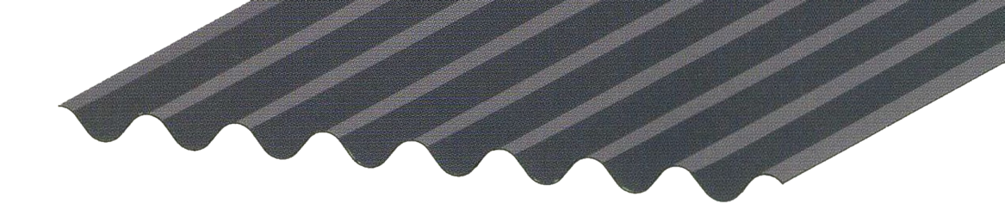6’

8’

12’

**MILD STEEL ONLY**

*26 Gauge*

GREAT FOR FENCE PANELS

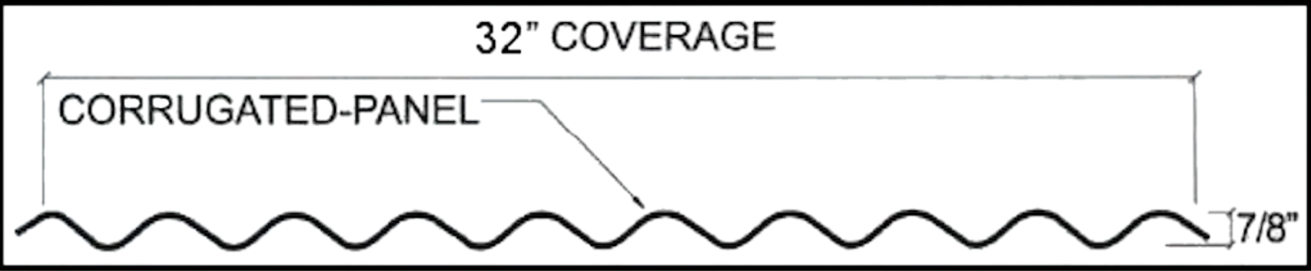

**RUSTING**

Our mild steel corrugated sheets are rustable. Rust may be obtained using our ***EasyRust Chemicals***, which will have an immediate reaction, or you let the outside elements take effect overtime.

Other chemicals that we carry provide a wide array of possibilities for your finish, so come in and ask a sales person for your options.